Irfan Ahmed
ICP 6
Due Date: 10/5/2020
The four hyper-parameters changed are(also few more for testing purposes):
- Epochs, Buffer size, Optimizer, Embedding dim, sequence length, batch size, temperature:
  - The number of Epochs is correlated with number of optimizations that are applied during training. Since having more rounds the training error will be reduced. But there is a high chance of overfitting the training data and it will start to lose performance. So, based on what I was testing the higher number of Epochs gave me the best result.
  - The optimizer I decided to use was ‘Adamax’ which is a variant of ‘Adam. It is based on the infinity norm. In most cases it is found to be better and I wanted to test that out with my model. Based on my testing ‘Adamax’ did perform better.
  - Few things would need be considered when changing the embedding dim matrix. Since, not every word would get replaced by a vector, and instead it is replaced by index. This index can be used to look up the embedding matrix. Also, the embedded vectors are updated frequently during the training process it would make since for this case to increase the embedding dim to large number if the dataset is large. Which was the case when I decided to use Hamlet by Shakespeare.
  - Batch size can be one of the most important hyperparameters that will need to be tuned. One of the benefits of going with a smaller batch size is that it will not converge to the global optima. Also, a smaller batch size is known to have a faster convergence to good solutions. This means that the smaller batch sizes allow the model to start learning before looking at all the data. I decided to go with slightly higher batch size but not too high. I wanted to have all the variable looked at and not have errors that would be hard to account for.
  - The sequence length was changed as well to see if it would affect the output and based on my trial and error, I did not notice any change.
  - The temperature was also changed to higher number to see if the text generation would improve but it made it worse. Higher the number the worse the output.

  - What you learned in the ICP
One of the main takes away from this ICP 6 was understanding how the hyperparameters affect the data output. Changing the batch size can impact it negatively or positively. Based on my observation the higher the batch size performed better. This could be due to the large dataset that was being used. If I had used a smaller dataset the higher batch size would affect in negatively. Another, important take away from this ICP 6 was changing the optimizer and how it affects the training sample. Variant of ‘Adam’ was used (‘Adamax’), which did perform better in my opinion. But hard to discern the two. The Epochs also played important role during the training and by going with the greater number it yielded better results. Also, few other like sequence lengths and embedding dim were hard to distinguish how they were affecting the data output. But changing the temperature did show improvement when using a low value number instead of high.
  - ICP description what was the task you were performing
      - Imported the required libraries/packages.
      - Used nltk to download ‘gutenberg which contained various data that could be used for text generation.
      - Used the raw data (nltk.corpus.gutenberg.raw(‘shakespear-hamlet.txt’)
      - Printed out the few character to see what the data looks like.
      - Created unique set of character in the file and sorted. Total of 67 unquiet character found in the data.
      - Mapped the character using enumerate by passing in the vocabular data set created(described in step 5).
      - Sequence of length initialized to 200. Then the text is divided into example sequence. Example_per_epoch = len(hamlet_text)//(sequence_length + 10).
      - Next the bath method applied to convert individual character to the desired sequence.
      - Then the sequence is duplicated and shifted to form the input and target text. For this the map method is used.
      - Looking at the input data and target values. Using print()
      - Created batch size, buffer size and the used dataset.shuffle on the buffer size .
      - The model defined and created. Also, the summary was looked at.
      - The output distribution was sampled and printed out the array list .
      - The model was trained and compiled. Also, the check points configured
      - The data was executed using 700 epochs.
      - Prediction loop was defined to generate the text.
      - Output the text.
  - Challenges that you faced
With practice I think I will get better at this. But had few issues trying to add more layers to the model. Also, trying to figure out how the hyperparameters affect the overall model performance. Feedback would be appreciated on what books to have when learning the neural network algorithms.
  - Screen shots that shows the successful execution of each required step of your code
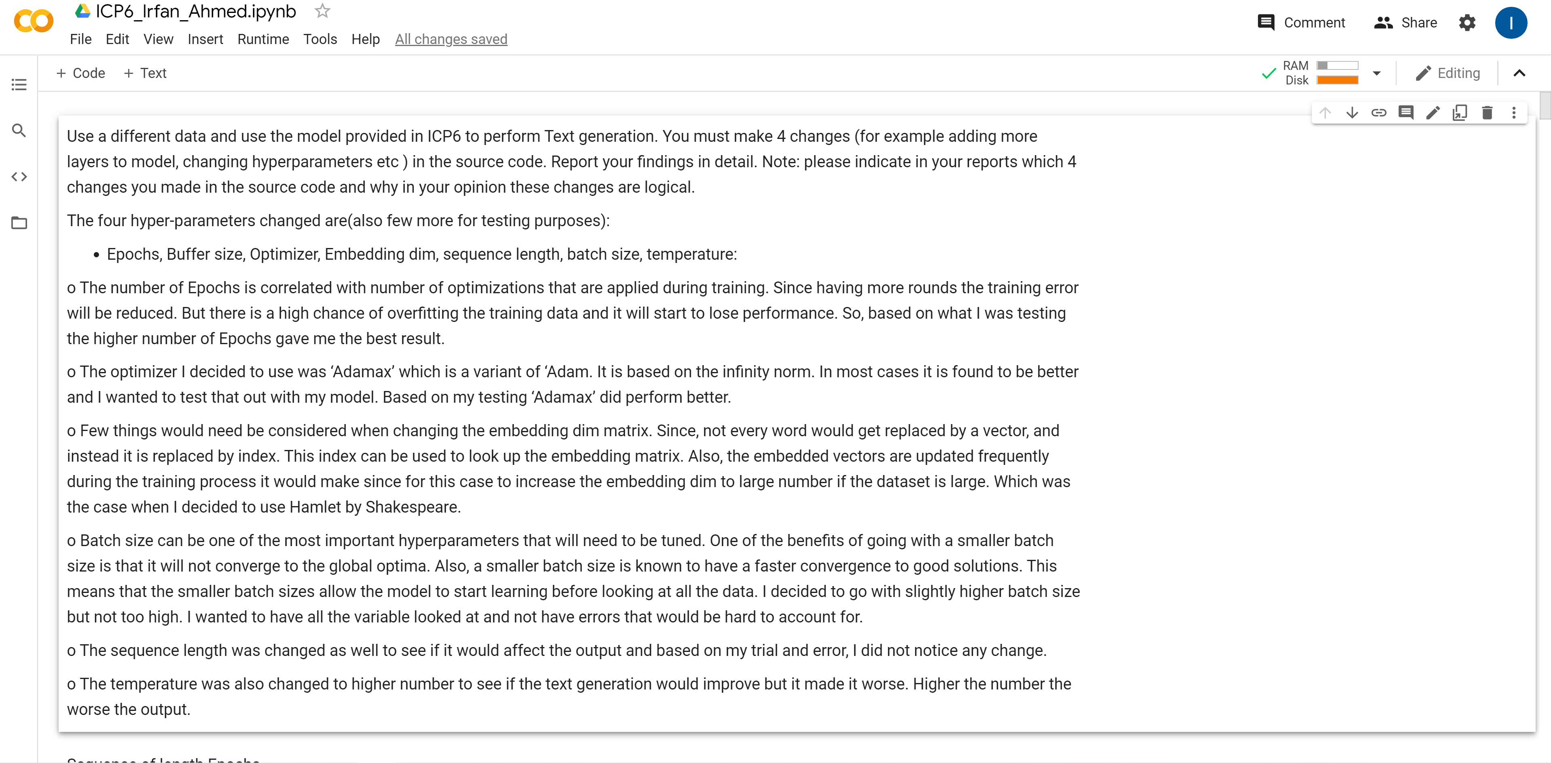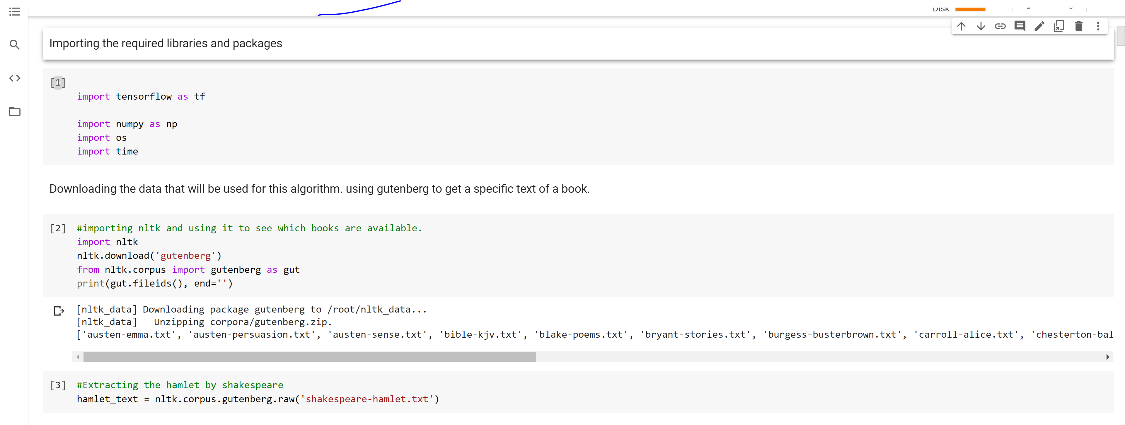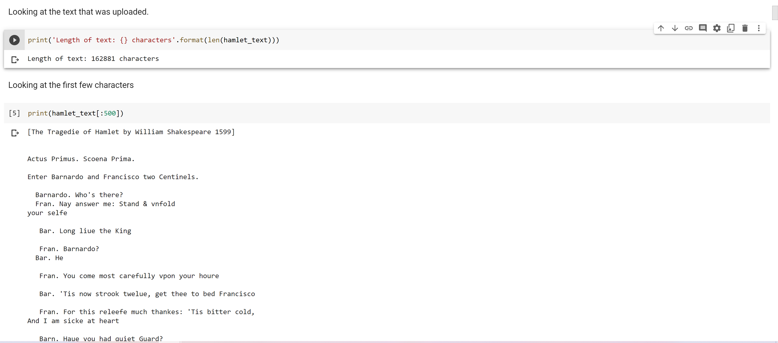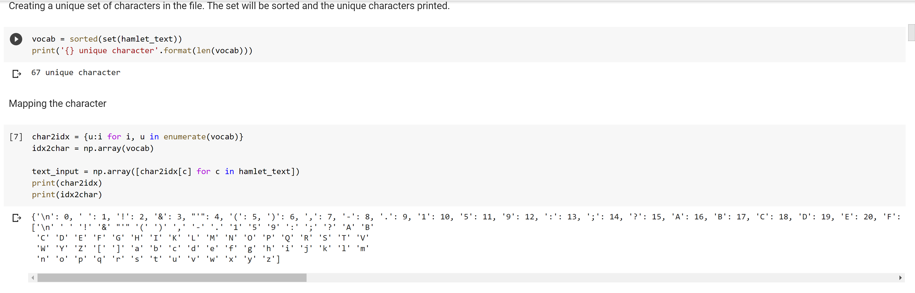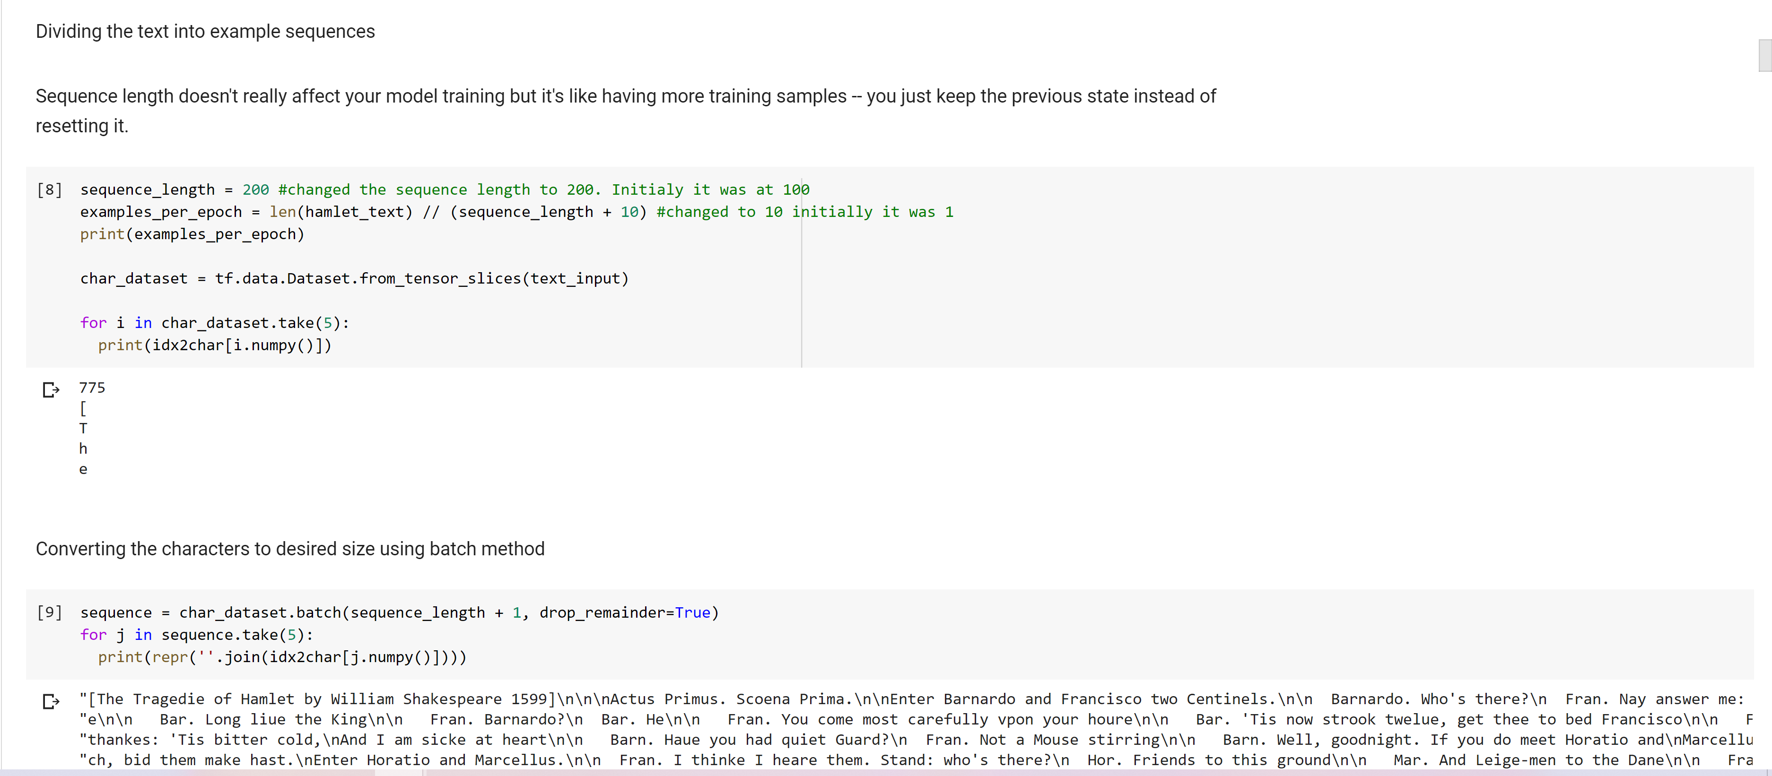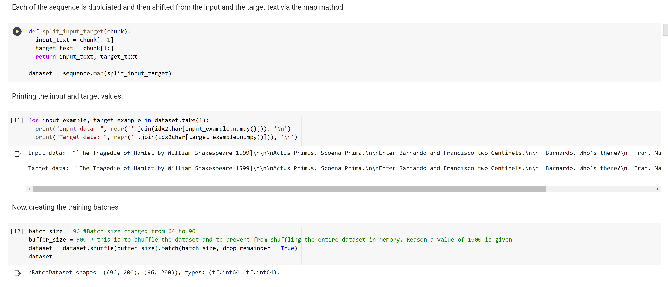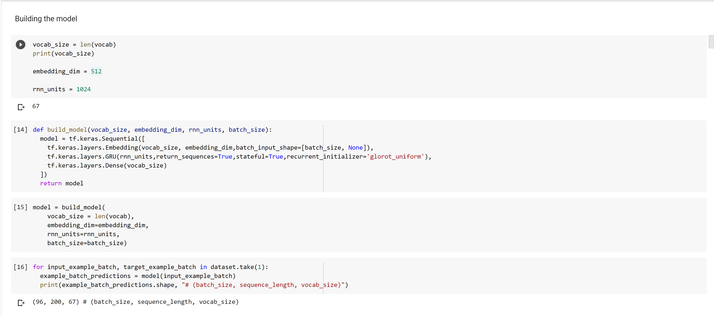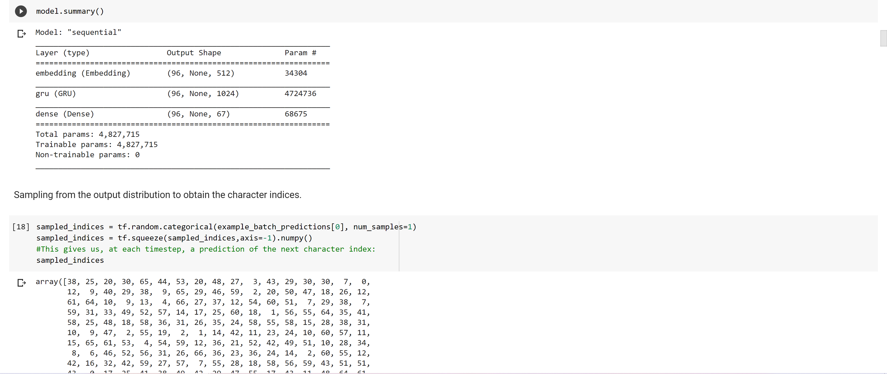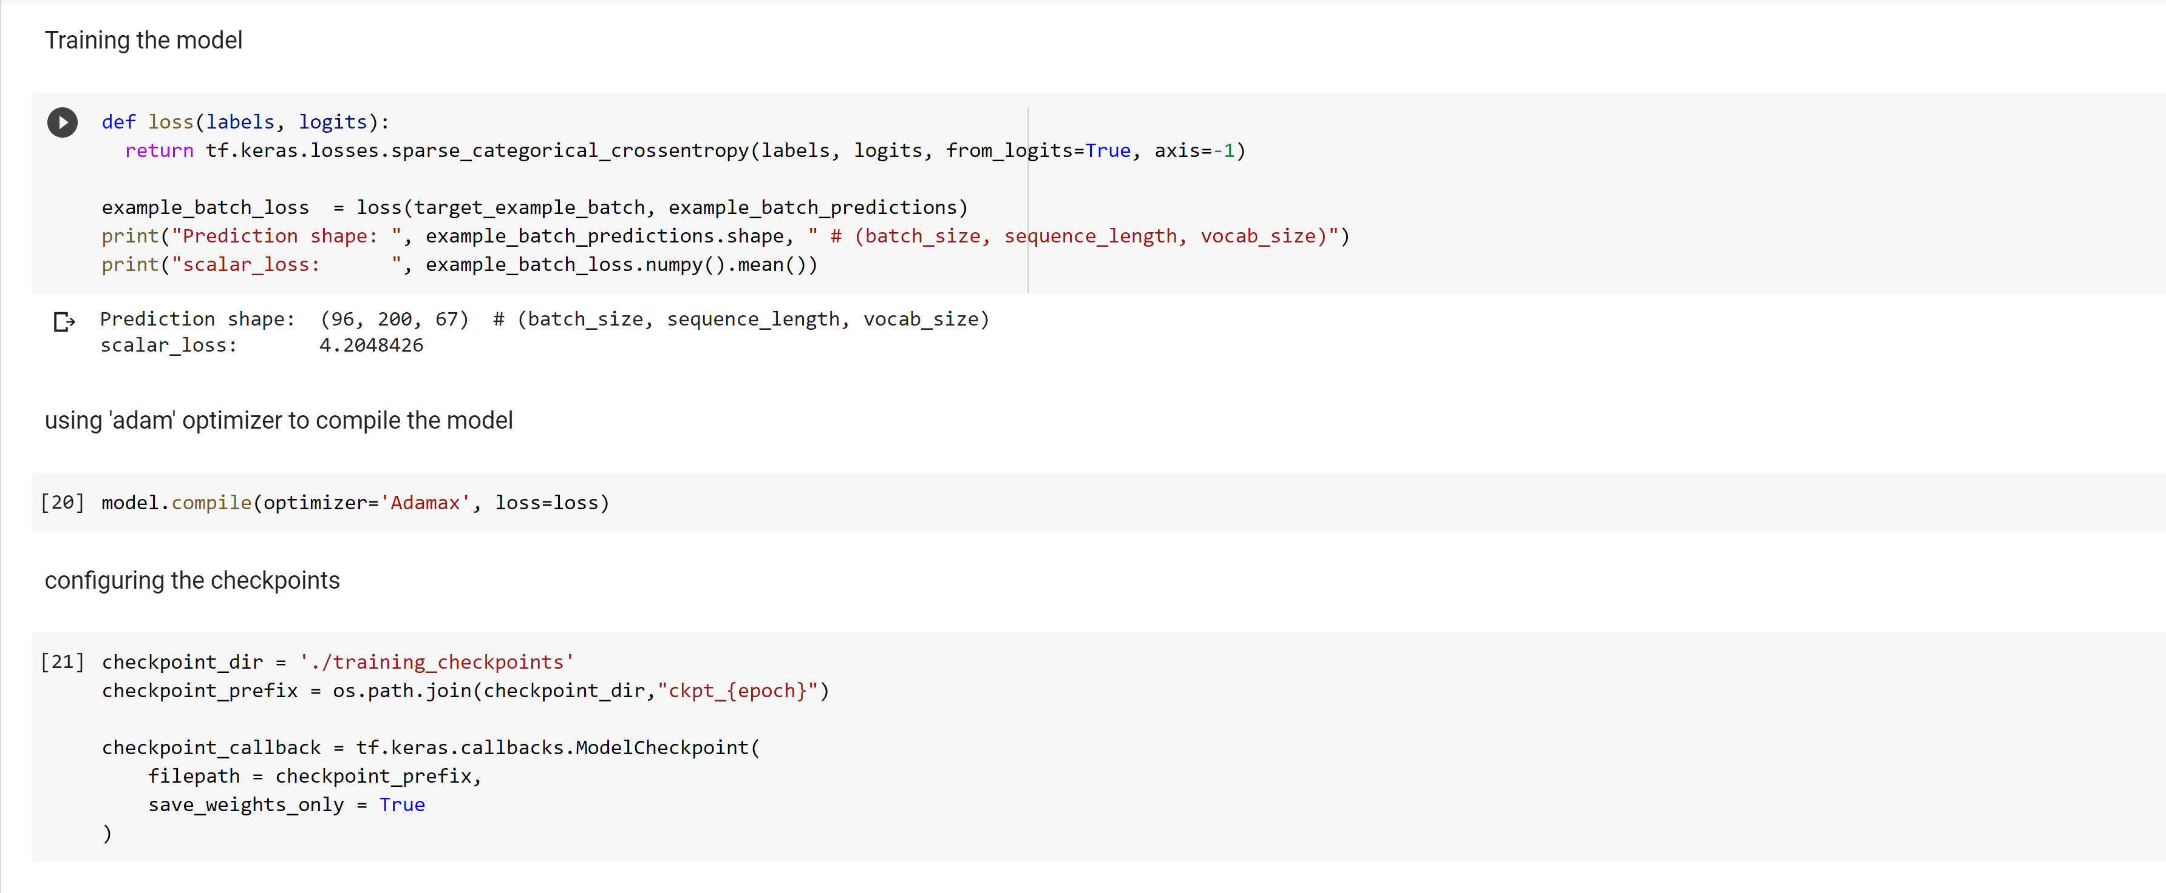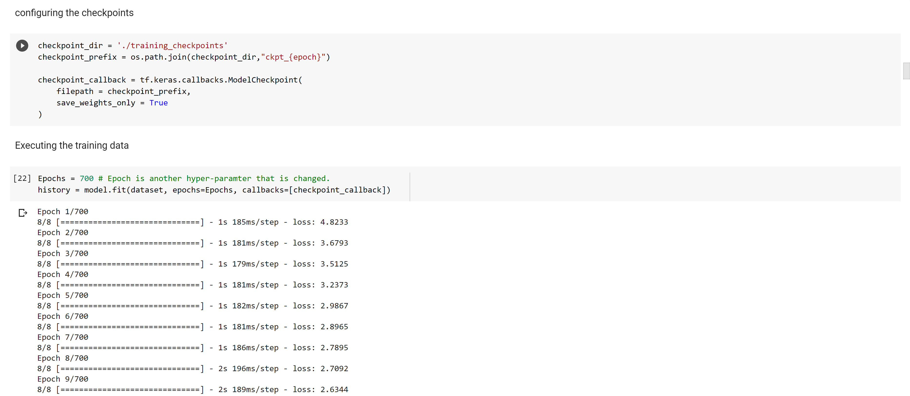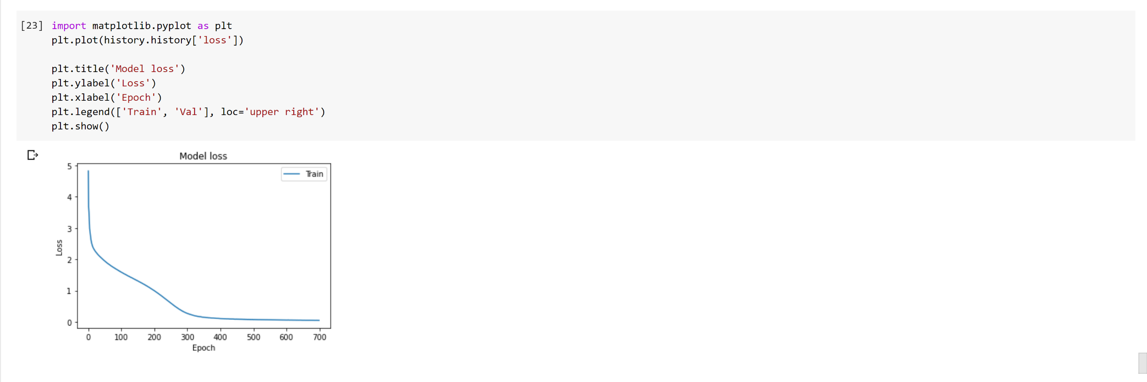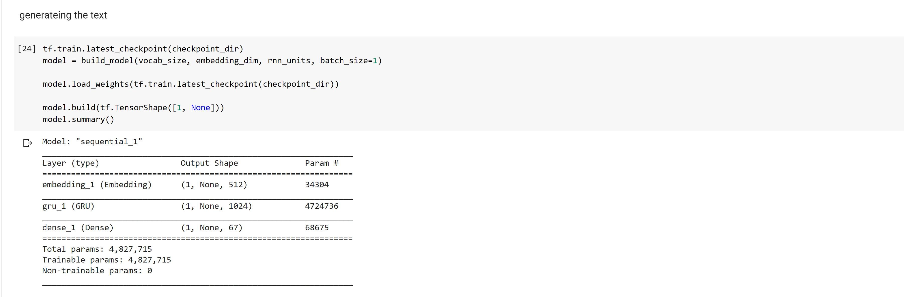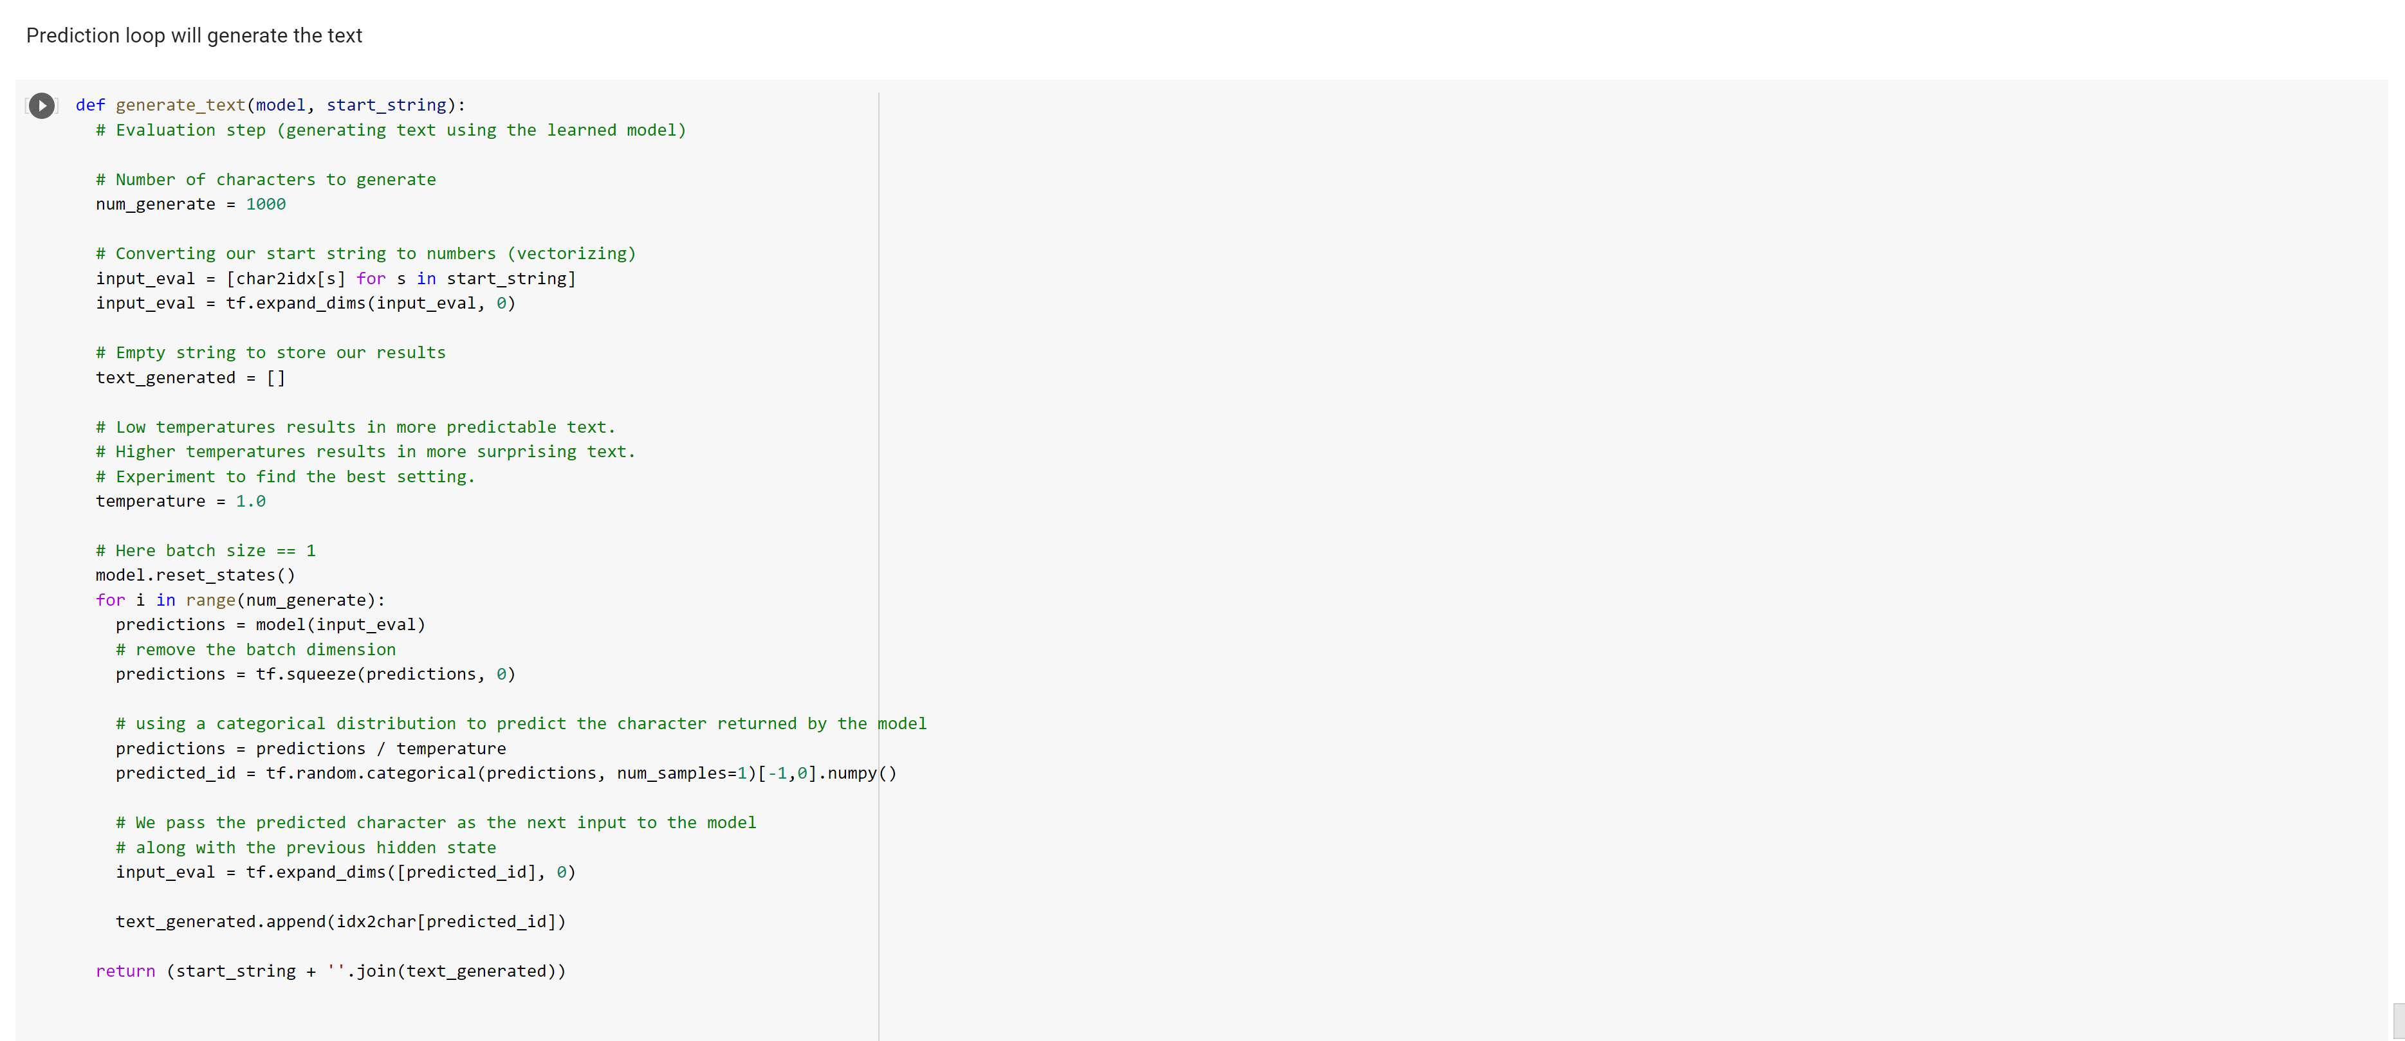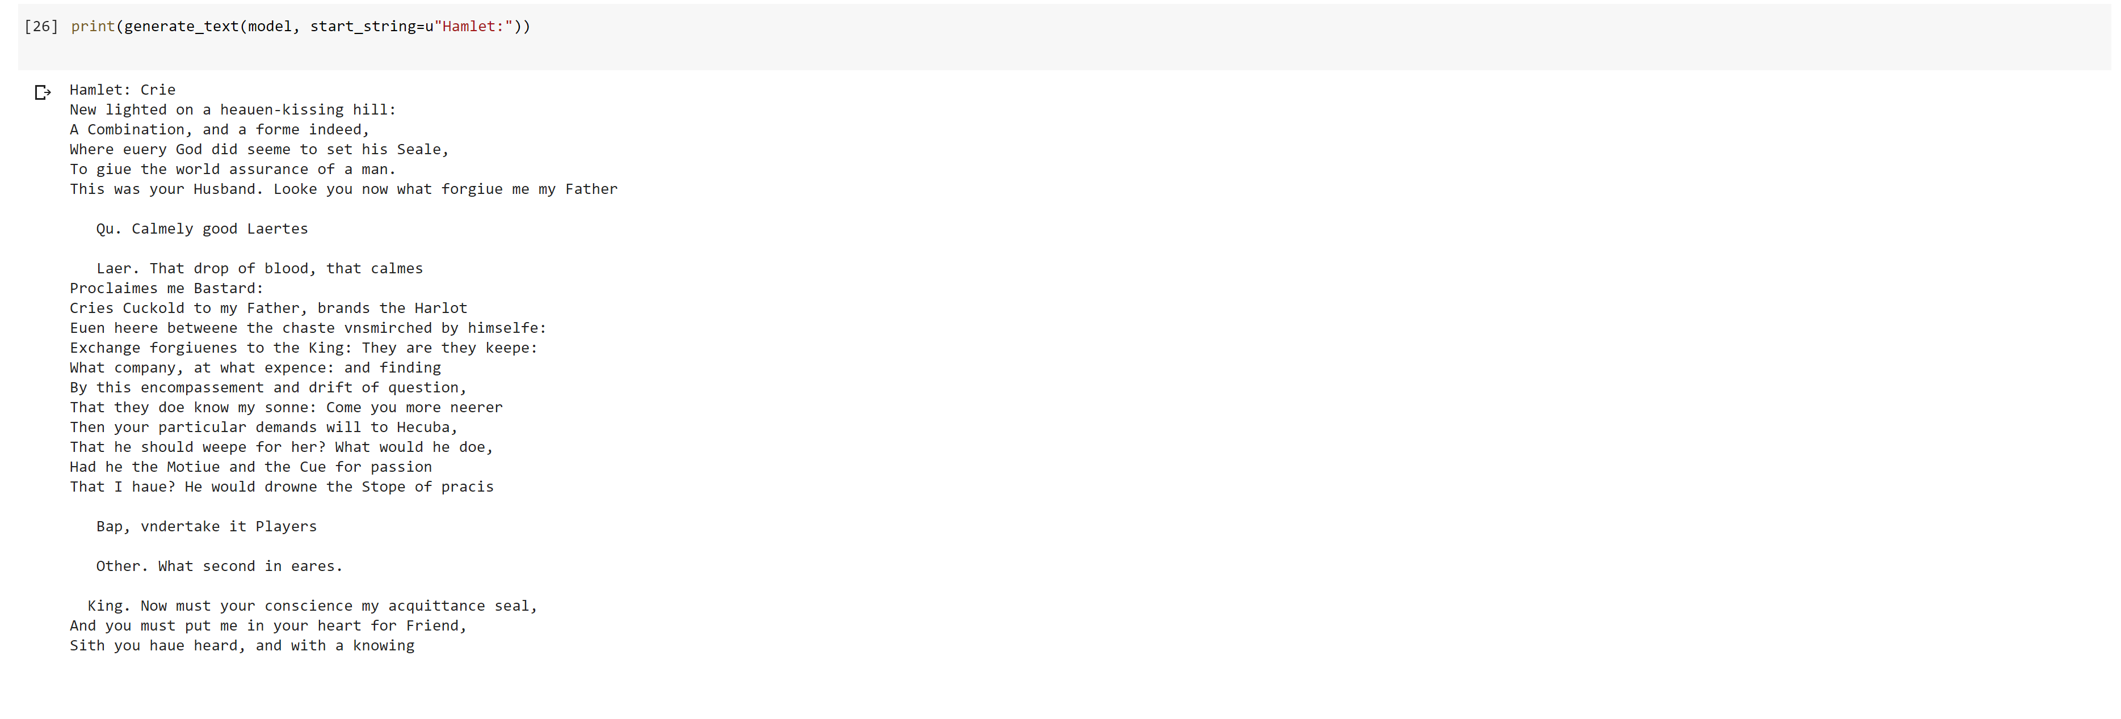

  - Output file link if applicable
https://github.com/UMKC-APL-BigDataAnalytics/icp6-irfancheemaa

  - Video link (YouTube or any other publicly available video platform)
https://umkc.hosted.panopto.com/Panopto/Pages/Viewer.aspx?id=269042d7-f5f0-4b83-8314-ac4b0189875e

  - Any inside about the data or the ICP in general

Overall, very interesting topic to learn about. I would like to have more background in the code itself. Try to fully understand how it all interacts. But enjoy it so far.

